**Lab Assignment 2**

**Were Vincent Ouma**

**BUSINESS ANALYTICS: DATA, MODELS AND DECISIONS**

**Homework 10**

**Question I**

The variables included in the model as predictors were Passenger ID, sex, Pclas, Fare, Embarked, Parch, Age and SibSP.These variables were flaged with either Orange or Green colors and also marked as shown below.

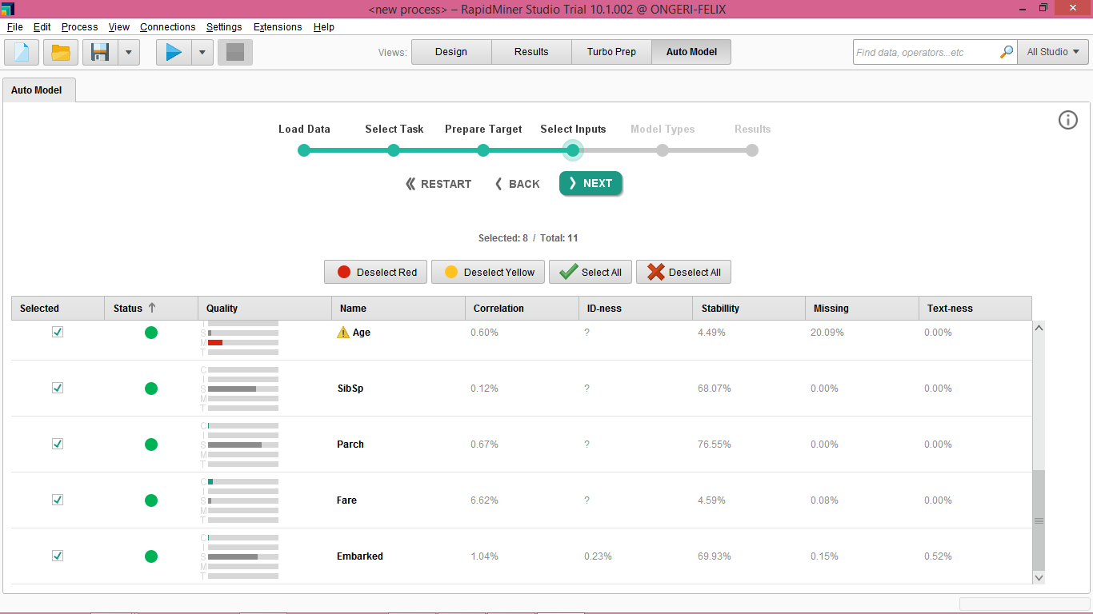

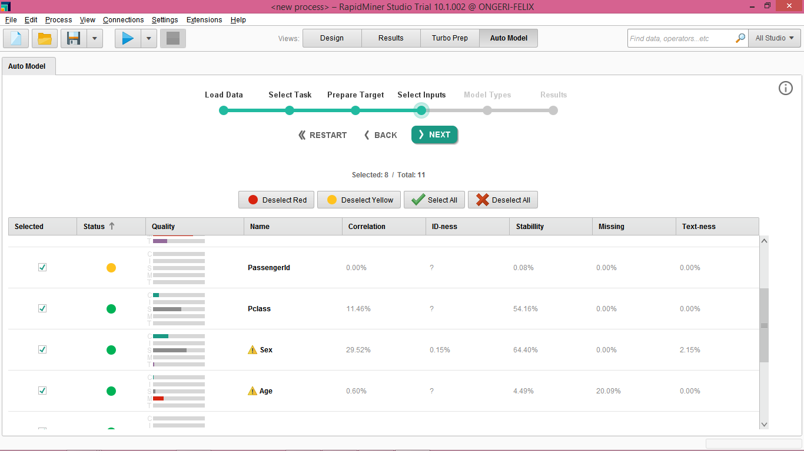

**Question II**

Random forest was found to be the best algorithm for the prediction. This is because it had the highest AUC of 0.903, this led to producing the best outcome.

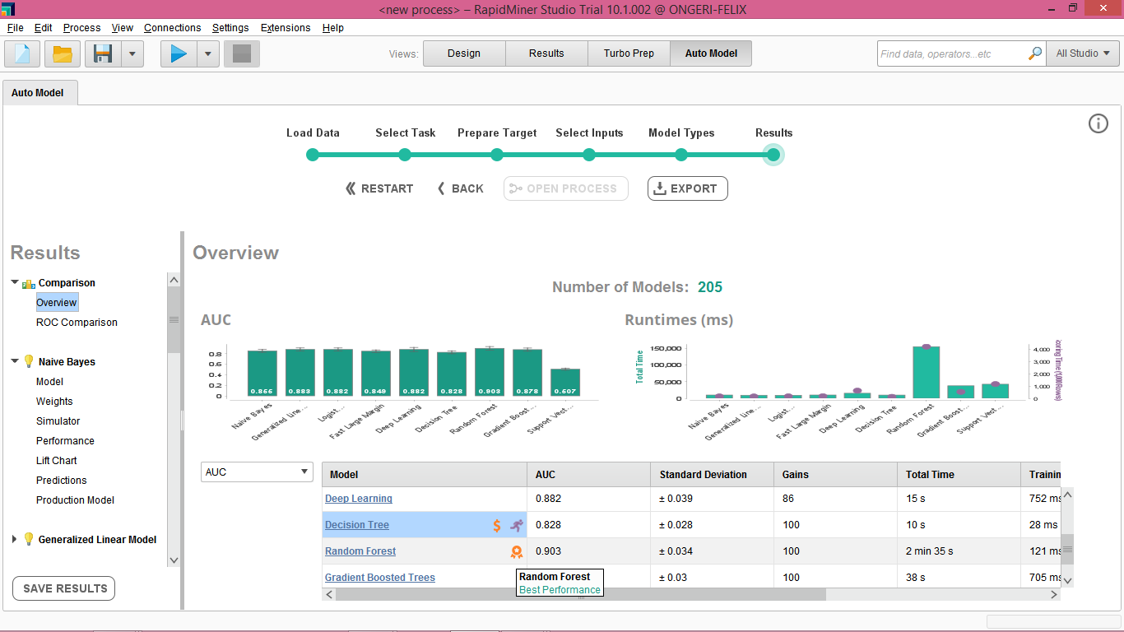

**Question III**

Sex was the most important predictor in the model. This can be determined by the weights in the correlations as shown below.

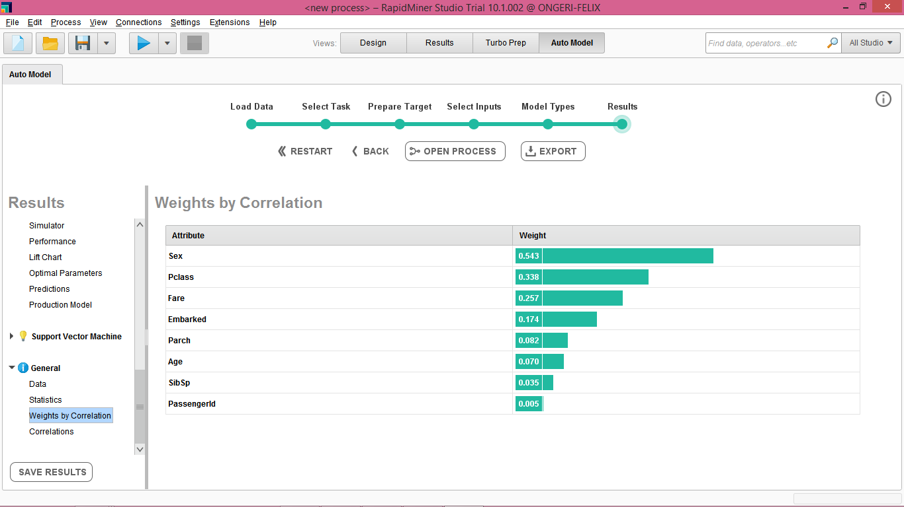

**Question IV**

The file for the Random forest algorithm is exported as RandomForestPredictions.xls